Martino Nikolovski | Nayeem Bhuiyan | Manisha Sharma | Eric Hunt

Nikolovski23@gmail.com | nyembn@gmail.com | manishasharma93@hotmail.com | theeric141992@gmail.com

# **Medical Health Record Sharing System ®**

PROVIDED BY

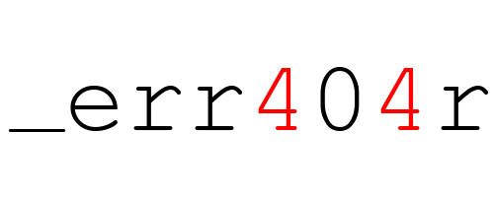

Contents

**Medical Health Record Sharing System ®** 0

SPECIFICATIONS 2

INTRODUCTION TO THIS PRODUCT 2

EXPORTING THE PATIENT’S RECORD FROM THE OPENEMR DATABASE 2

SHARING THE EXPORTED PATIENT’S RECORD 2

DECODING EXISTING ENCODED PATIENT RECORD 2

PREPARATION FOR THE SETUP 3

INSTALLATION OF JAVA JDK OR JRE 3

OPENEMR SETUP 8

INSTALLING XAMPP 8

ADDING TOMCAT MANAGER GUI USER 15

INSTALLING OPENEMR 16

REPLACING THE PATIENT REPORT FILE 17

STARTING THE SERVERS 18

ADDING SQL STATEMENTS 19

DEPLOYING THE MHR SHARING SYSTEM WAR FILE IN TOMCAT 21

INTERACTION GUIDE 22

TESTING DATA 28

SOFTWARE LIMITATIONS 29

# SPECIFICATIONS

## INTRODUCTION TO THIS PRODUCT

Our team developed a module/feature for Open EMR medical system, that will save time and effort in sharing patient information between medical offices. This feature will be user-friendly, intuitive and simple to use.

There are 3 main components of this feature:

* Extracting the patient’s record from the openEMR database
* Sharing the exported patient record through email
* Decoding existing encoded patient record

These will be discussed in detail in the following sections.

## EXPORTING THE PATIENT’S RECORD FROM THE OPENEMR DATABASE

Exporting the patient’s record from the database follows the below stated procedure in sequential way:

* Establishing connection to the openEMR database with the predefined credentials which will have certain access privileges.
* Querying the database for a specific record.
* Converting the returned results from the query to a special XML format for medical records, CCD (Continuity of Care Document) which is a standard format for electronic health record.
* Protecting the converted CCD file by 128bit AES encryption before sending.

# SHARING THE EXPORTED PATIENT’S RECORD

Sharing the record is through email API (JavaMail) which is *implemented* and *pre-configured* in the feature to send email with the health record as an attachment.

Sending the CCD file can be seen as a procedure that follows the following pattern:

* Attaching the CCD file which is located on a temporary directory on the sending workstation will be done in the background.
* Getting the email address from the html form on the feature’s page and setting it as the target email.
* Sending the email with the attachment through the preconfigured SMTP protocol.

## DECODING EXISTING ENCODED PATIENT RECORD

The decoding will be done in a way that gets the filename which is the timestamp and the last 4 digits of the patients Social Security Number as a key and decrypts the file using 128bit AES decryption.

# PREPARATION FOR THE SETUP

## INSTALLATION OF JAVA JDK OR JRE

You can find the installation package available for download at <http://www.oracle.com/technetwork/java/javase/downloads/jdk8-downloads-2133151.html>

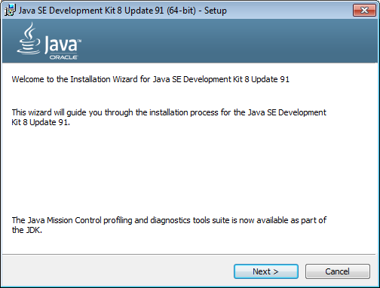

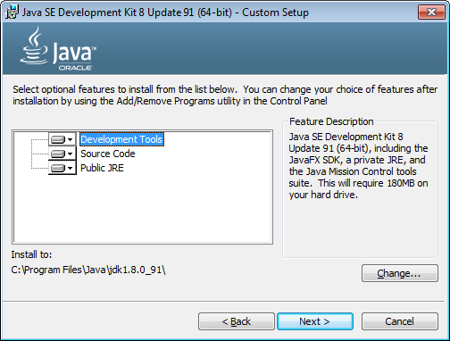

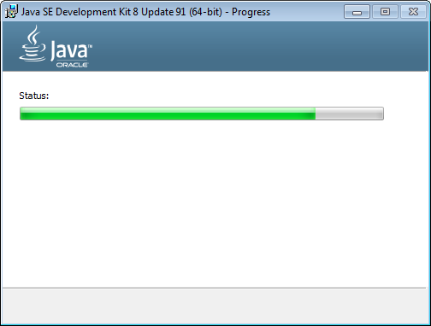

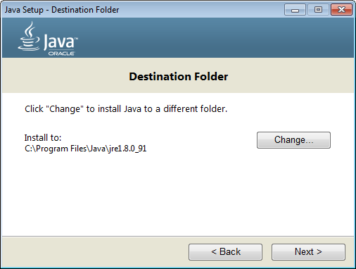

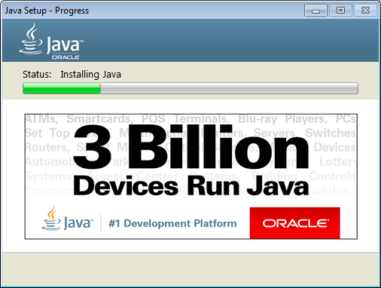

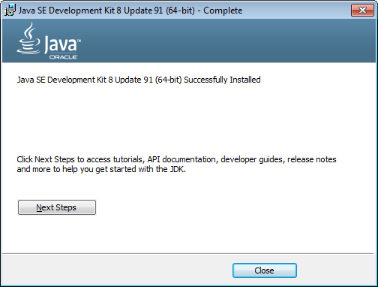

In the final step make sure that the JRE is included in the System PATH

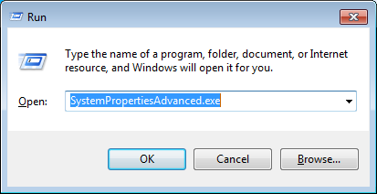

Run SystemPropertiesAdvanced.exe and then select Environment Variables on the popped up window.

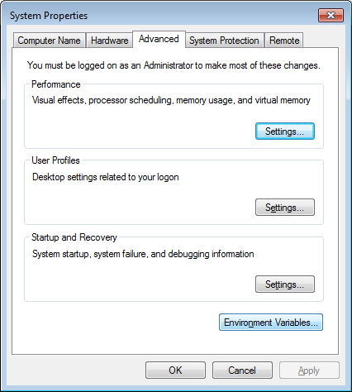

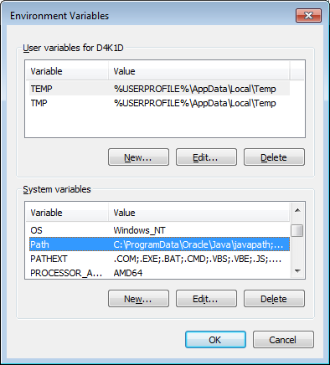

Double click on Path and then add the following line at the end of the text field:

C:\Program Files\Java\jdk1.8.0_91\bin;

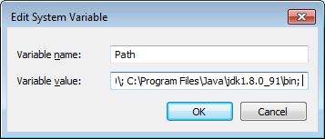

Click OK, then Click on New Variable.

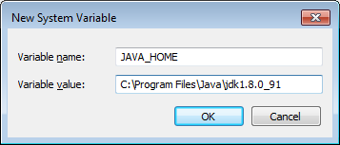

New Variable again.

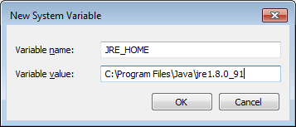

Close all open windows by clicking OK. The JDK and JRE has been successfully setup.

# OPENEMR SETUP

## INSTALLING XAMPP

You can download the installation package at <https://www.apachefriends.org/download.html>

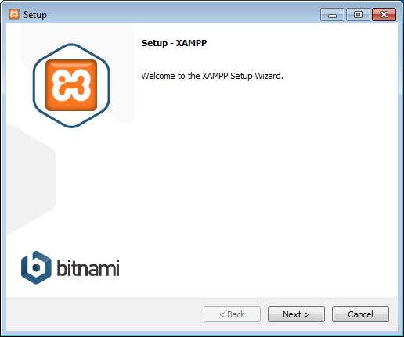

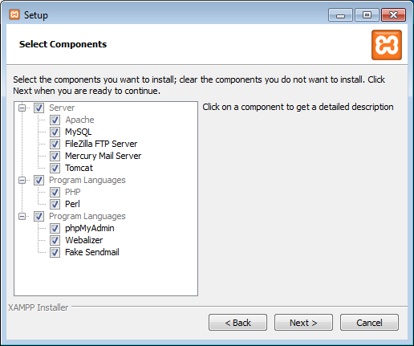

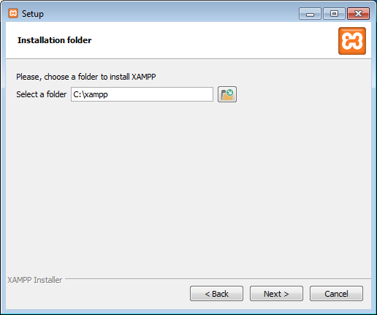

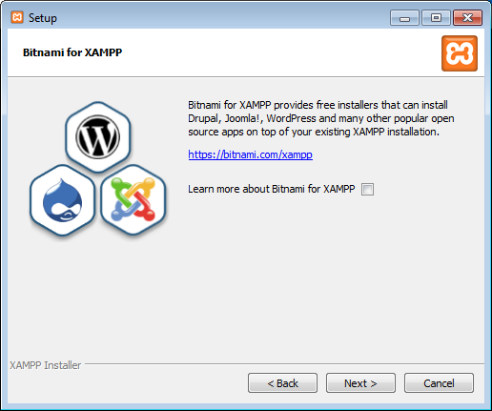

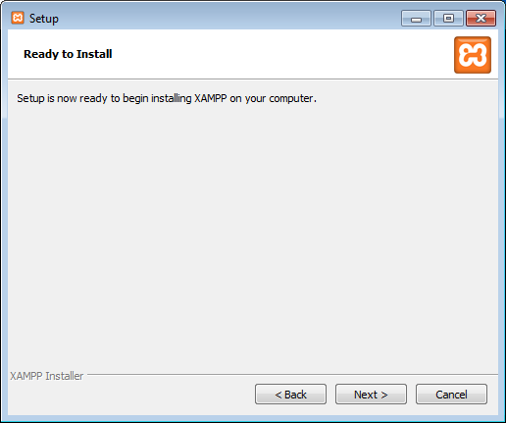

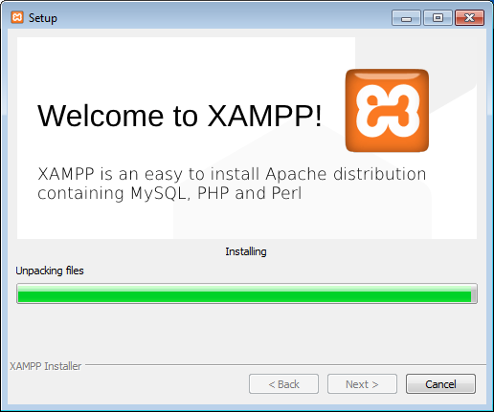

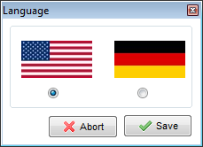

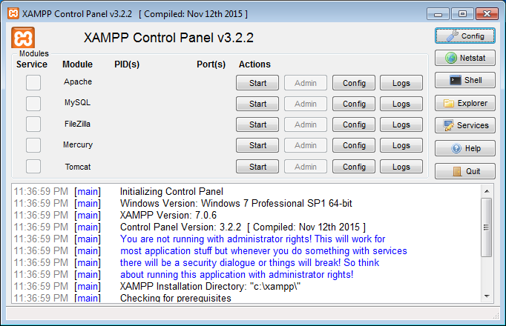

It is recommended that XAMPP is running with administrator rights because it needs permission to use some system background services needed to function properly. To run XAMPP with administrator rights, navigate to C:\xampp and right click on xampp-control.

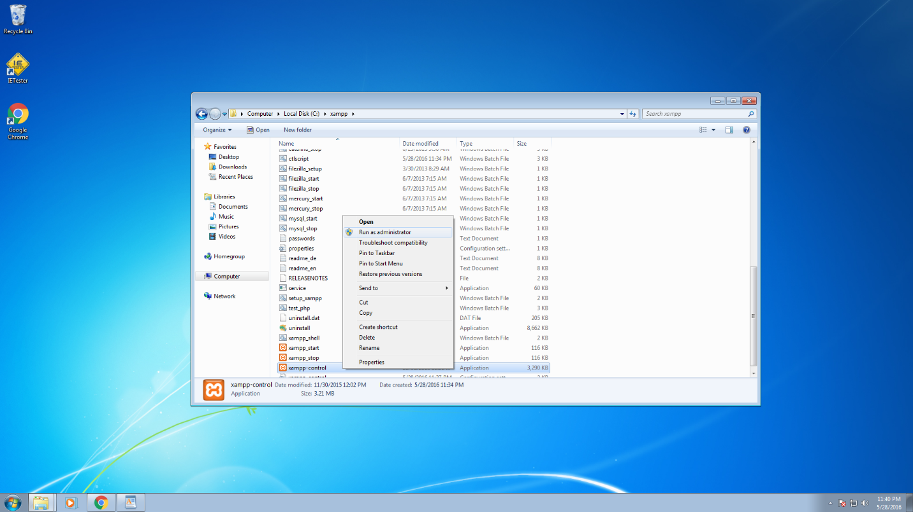

The following windows is shown and as you can see there are red X next to each server except Mercury. What we want to do now is click on each X and install the servers.

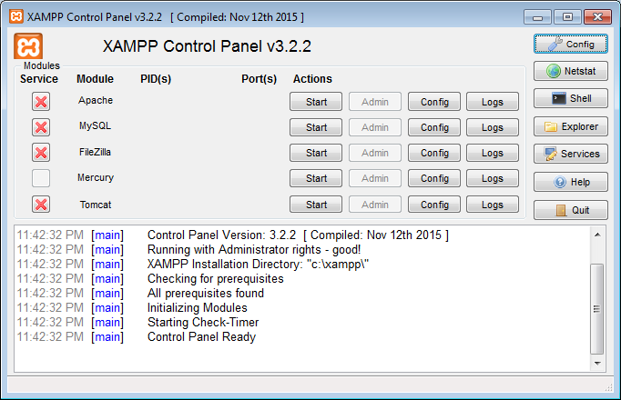

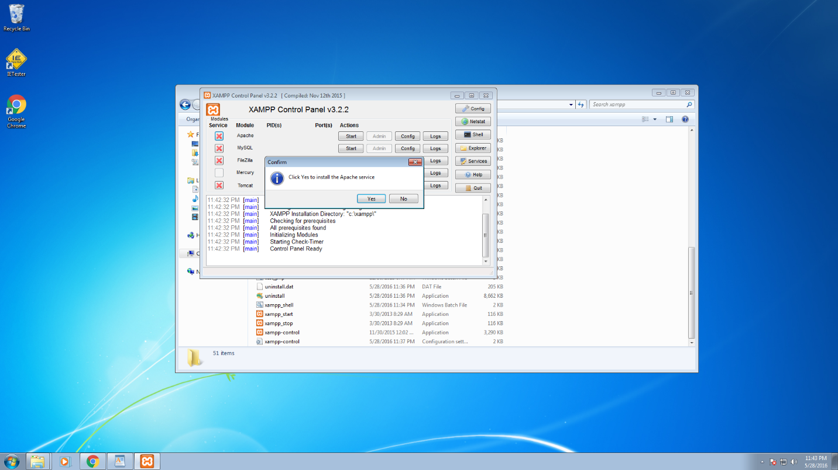

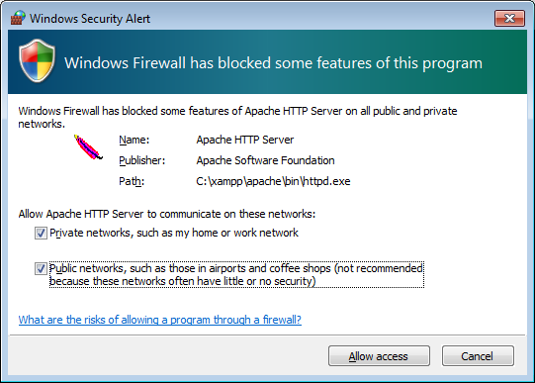

After all servers are installed here is the final result. If you have encountered an error for Tomcat server, you need to install Java JDK or JRE. You can find the guide under PREPARATION FOR THE SETUP section above. After installing Java JDK or JRE, Tomcat should be successfully installed.

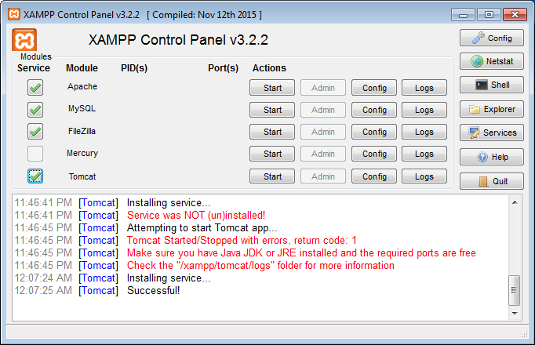

## ADDING TOMCAT MANAGER GUI USER

Adding a manager GUI user will help you deploy the war file of the MHR Sharing System add-on feature for OpenEMR easier.

While XAMPP Control Panel open, click on Config button in the last row where Tomcat server is shown.

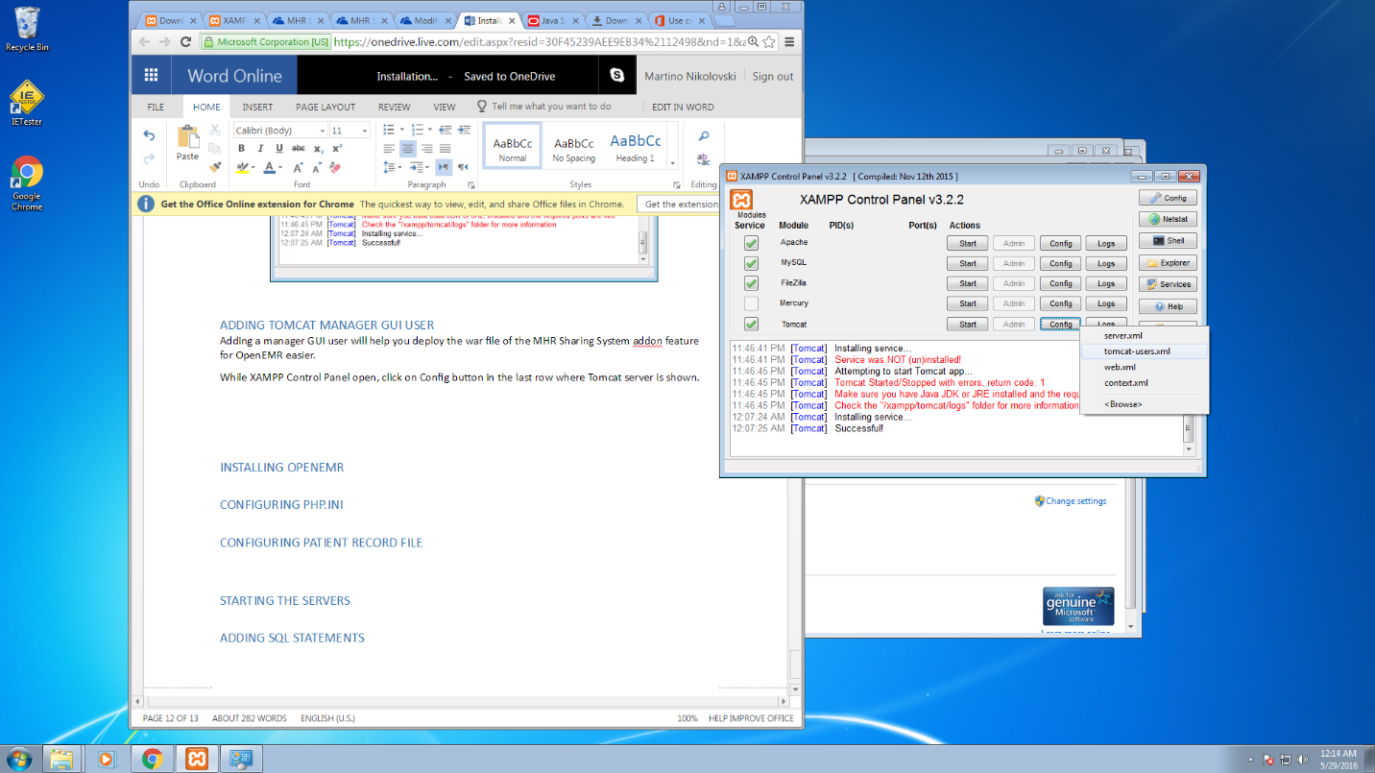

Add the following line with custom username and password.

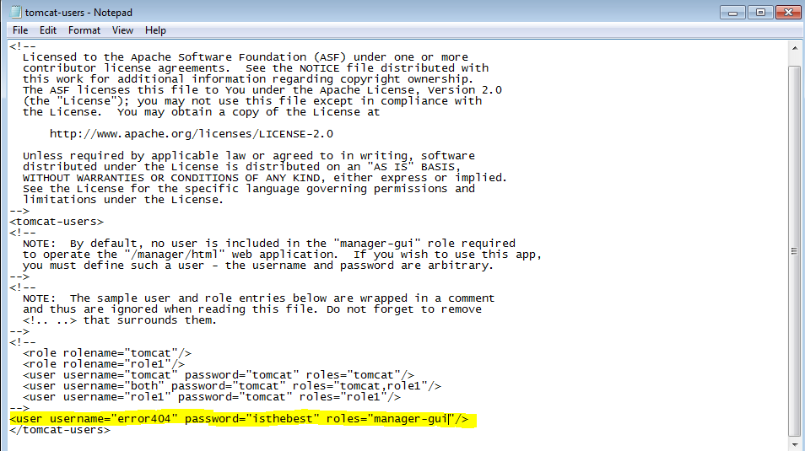

Save the configuration file by clicking Ctrl+S and close it.

## INSTALLING OPENEMR

Navigate to <http://www.open-emr.org/wiki/index.php/OpenEMR_Downloads> and choose the platform you are installing to. To be consistent with this guide that we have provided for you, we will select the Windows version. **After downloading the file, PLEASE follow the installation instructions that are provided on the openEMR website because they are crucial point of successful setup and run of openEMR**. Here is the direct link to it:

<http://www.open-emr.org/wiki/index.php/OpenEMR_4.2.2_Windows_Installation#Installing_OpenEMR>

Configuring the PHP.ini file is one of the important steps (I suggest making a backup to this php.ini file since it is known to cause trouble to the Apache server if not configured properly). Here is a screenshot which is part of the installation guide on the openEMR site:

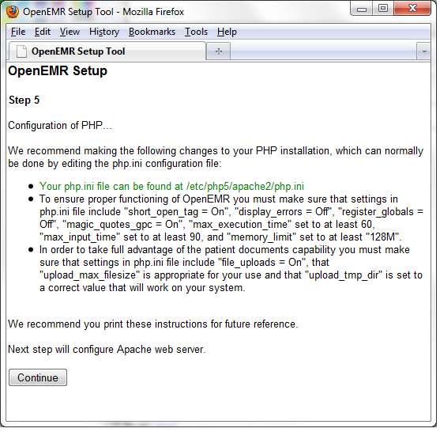

This configuration is for the versions earlier than 4.2.2. If you plan to install 4.2.2 and newer, then you only have to change:

display_errors=Off

max_execution_time=60

max_input_time=90

Optional changes:

upload_max_filesize=<size by need in MB>

**A preconfigured file php.ini can be found in the "Preconfigured files" folder which can be used to overwrite the existing php.ini file found in "C:\xampp\php\" directory.**

## REPLACING THE PATIENT REPORT FILE

In order openEMR to connect to the MHR Sharing System, the default patient_report.php needs to be replaced with the preconfigured one which can be found in the **Preconfigured folder**. The .php file that needs to be replaced can be found at **C:\xampp\htdocs\openemr\interface\patient_file\report**

**THIS SECTION IS IMPORTANT AND IF SKIPPED, THE MHR SHARING SYSTEM WILL NOT BE AVAILABLE TO OPENEMR.**

Once the patient_report.php is replaced you will see a button "Share Report".

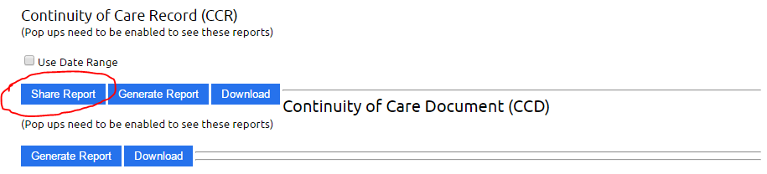

## STARTING THE SERVERS

Run XAMPP Control Panel as Administrator and click start where Apache, MySQL and Tomcat rows. If problem occurs when starting Tomcat, there is a quick fix that can be done to start working properly. Navigate to **C:\xampp\tomcat\bi**n and run **tomcat7w.exe.**

Under Java tab, select Use default.

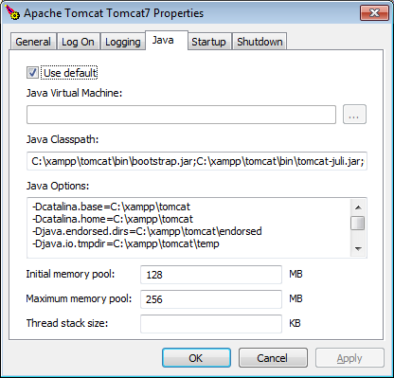

Under Startup and Shutdown tab, choose Mode: Java

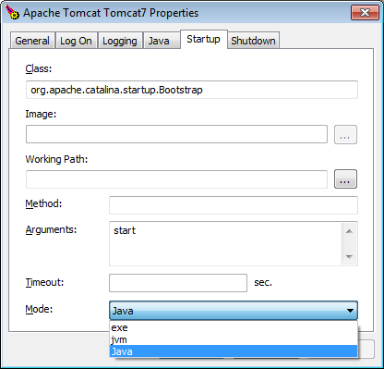

## ADDING SQL STATEMENTS

In order to have sample patient data you have to import the .sql file into the patient_data table in localhost/phpmyadmin (by default it will log you in automatically unless you have changed the root password). The patient_data.sql can be found in the SQL Statements folder.

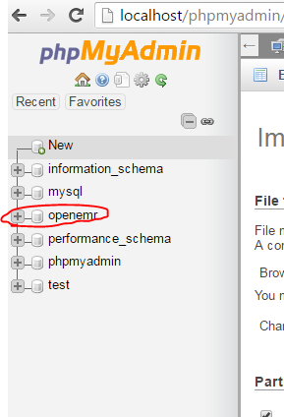

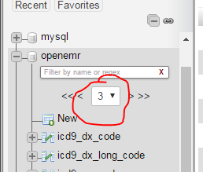

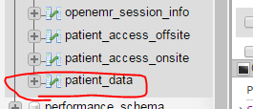

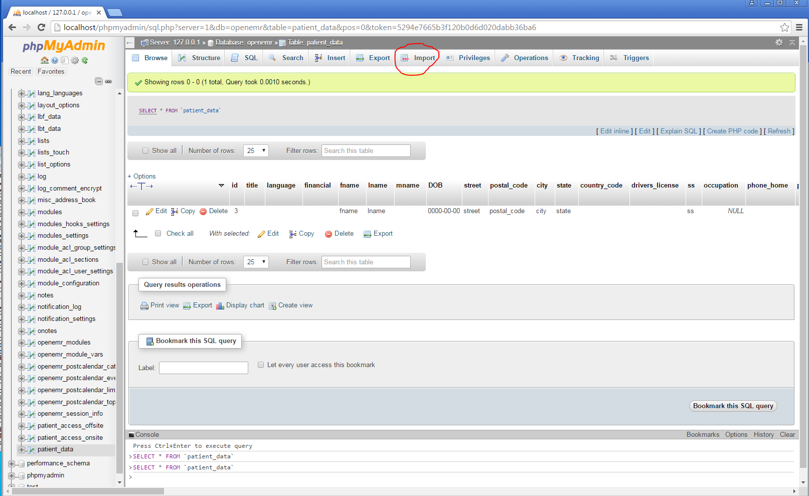

Click on GO and the query will be executed with 1000 sample patients.

## DEPLOYING THE MHR SHARING SYSTEM WAR FILE IN TOMCAT

Before starting with the deployment please make sure that Tomcat is running in XAMPP.

Navigate to **localhost:8080/manager** in your browser and use the username and password you have already set up. Go to ADDING TOMCAT MANAGER GUI USER and set one up. There are 2 options of deployment.

OPTION 1:

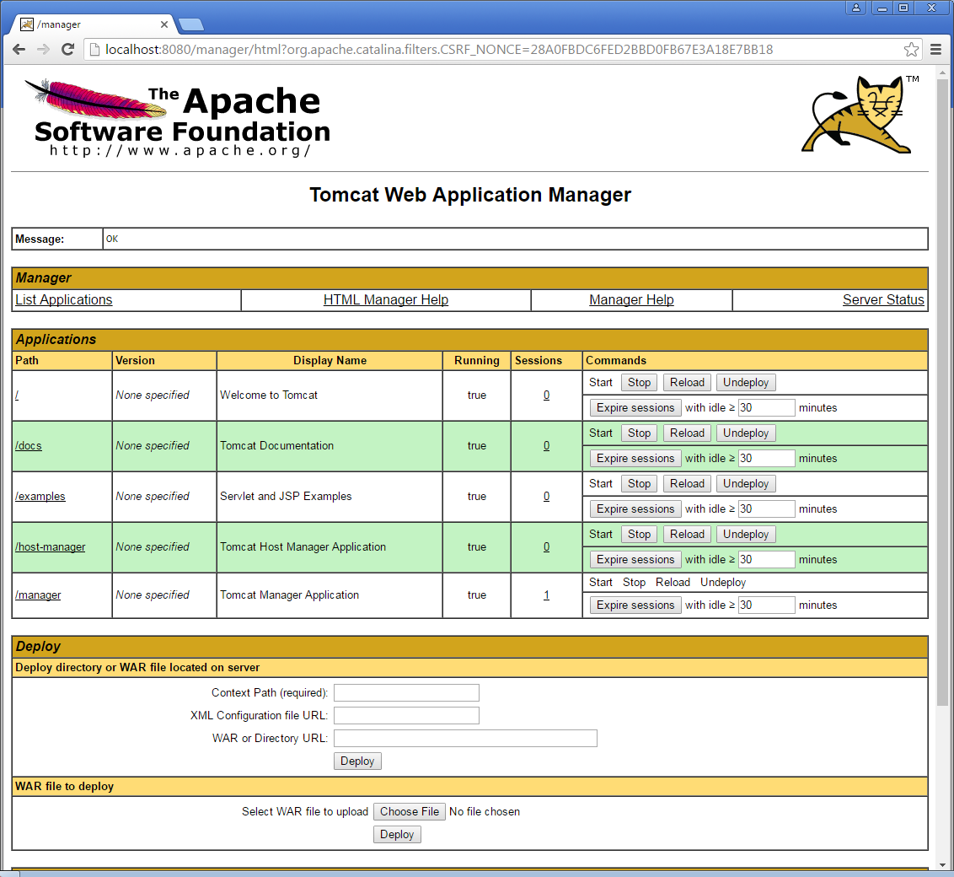

Undeploy Path / then enter the following information In the "Deployment directory or WAR file located on server" section. The WAR or Directory URL is different for every user so give your path name of the MHRSharing.war (which by default will be located in the project folder)

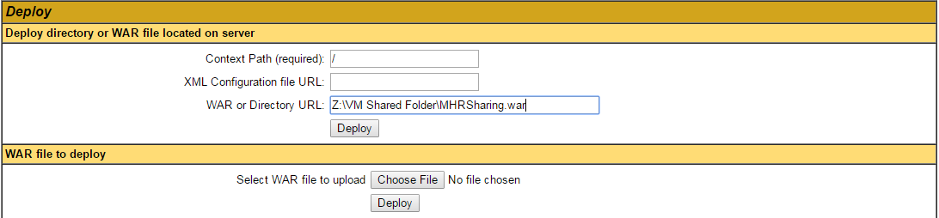

OPTION 2:

Copy the contents of MHRSharing_war folder into **C:\xampp\tomcat\webapps\ROOT\** (delete everything that is there first).

## INTERACTION GUIDE

When openEMR and MHR Sharing system are installed and configured, and Apache, MySQL and Tomcat are running we can proceed and go through the interaction guide.

Navigate to localhost/openEMR

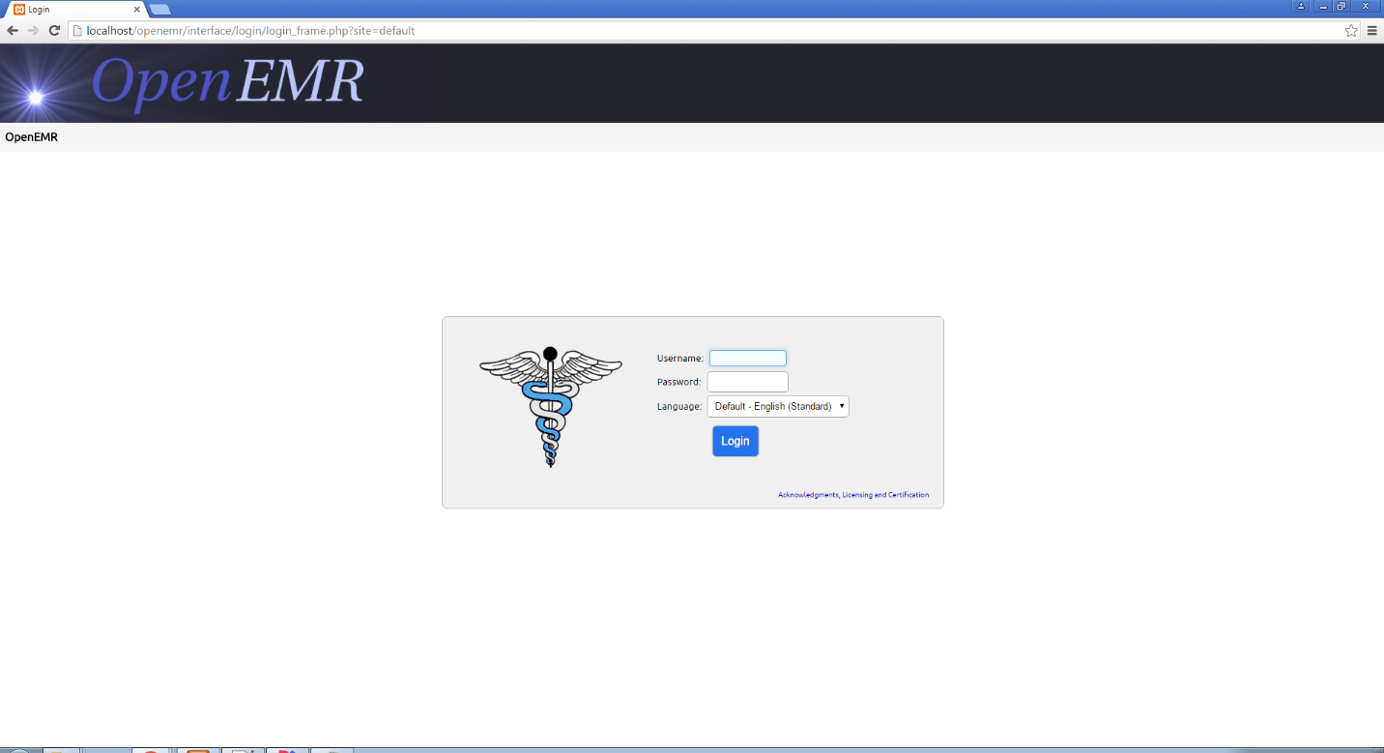

Enter the username and password you have configured during the installation of openEMR (INSTALLING OPENEMR) and click login. Then click on patient and there should be sample patients from the SQL query.

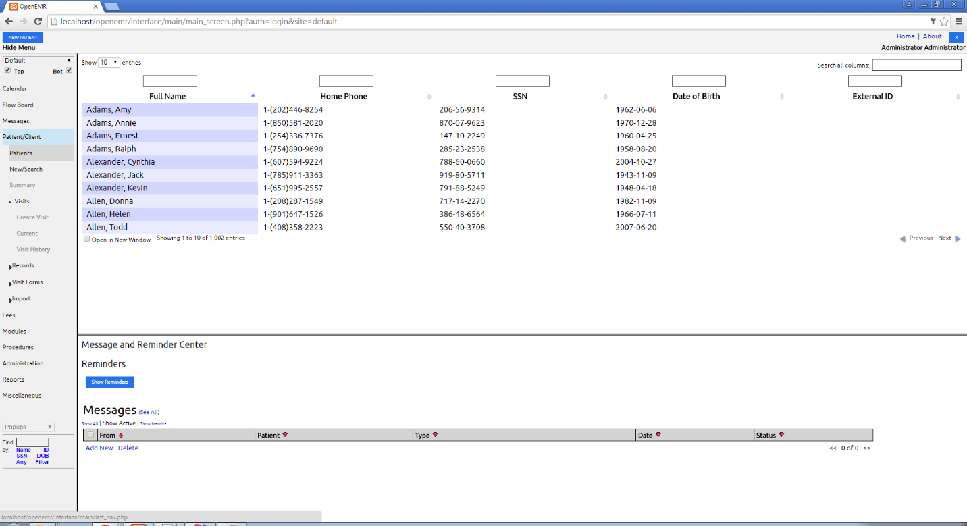

Click on any patient and then choose Record on the top of the page (for example Amy Adams with id 359)

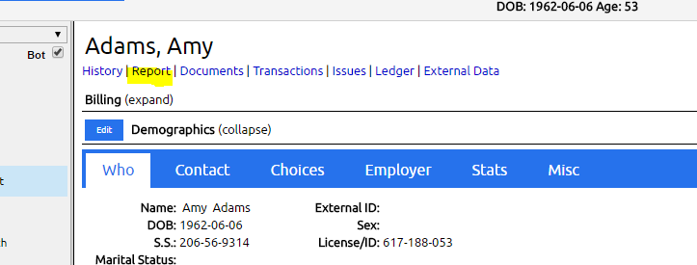

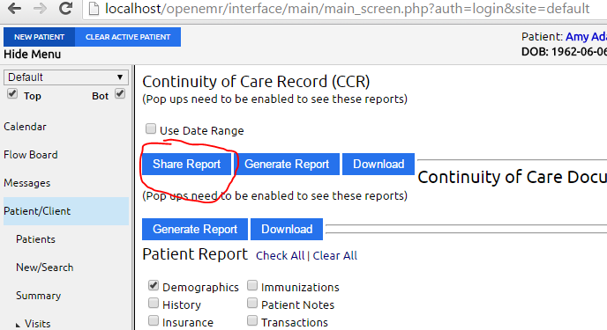

A new window will pop up looking like the following:

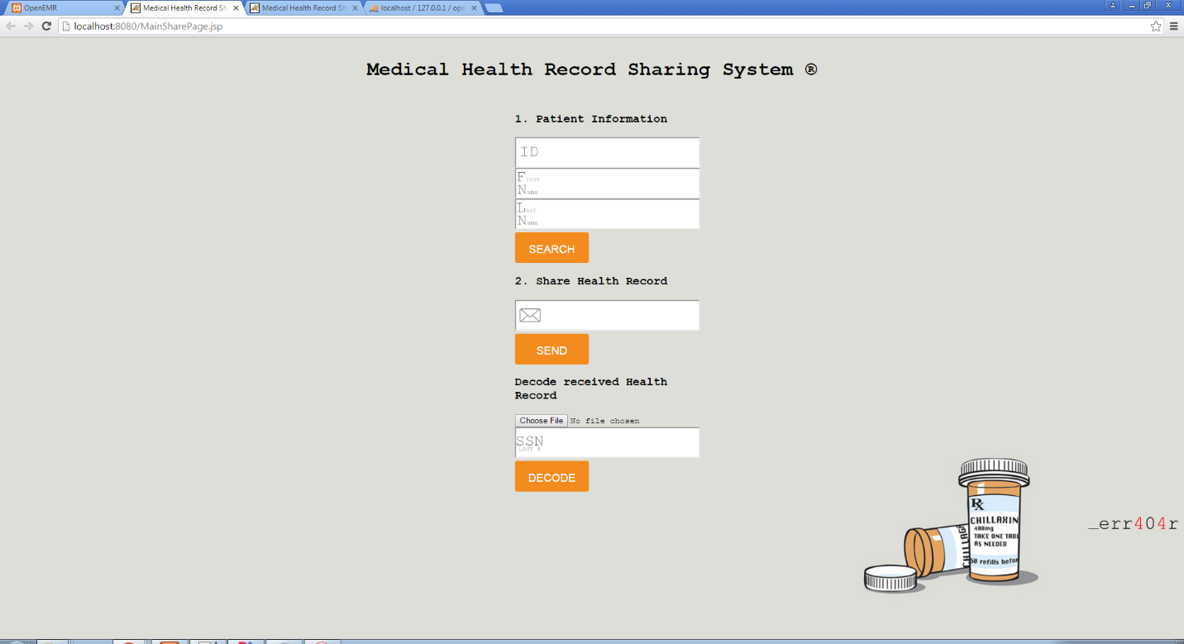

Under ID enter **359**, under First name enter **Amy** and under last name enter **Adams**

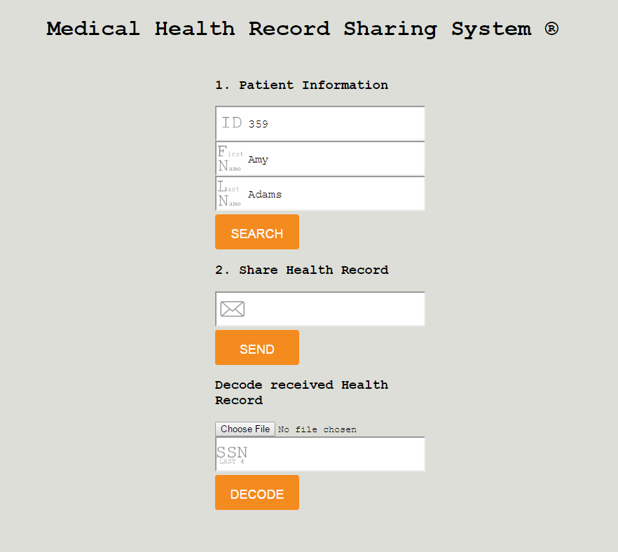

Click Search. If found it will show the following.

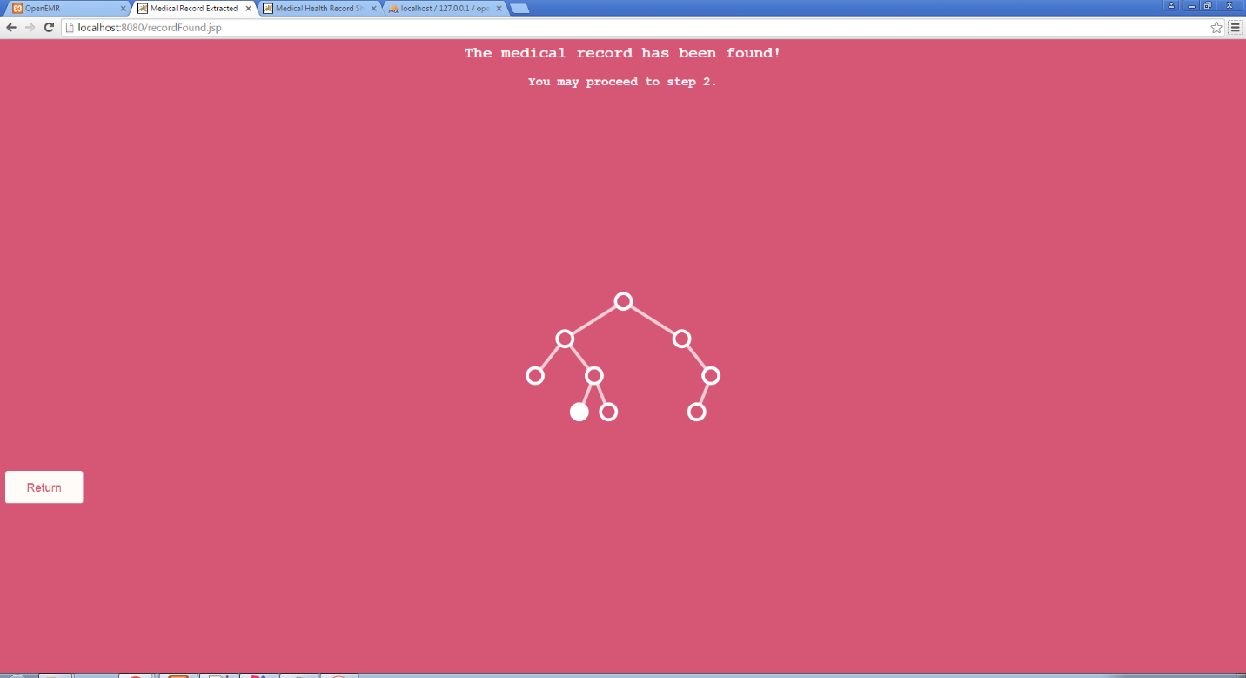

Click return and enter the destination email.

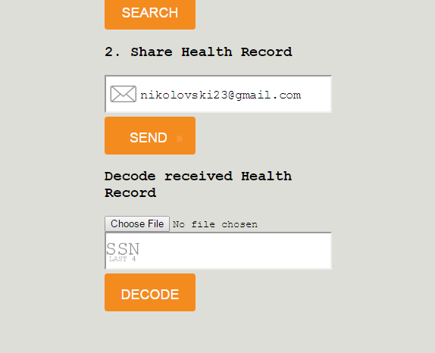

Click send and the following page should show up:

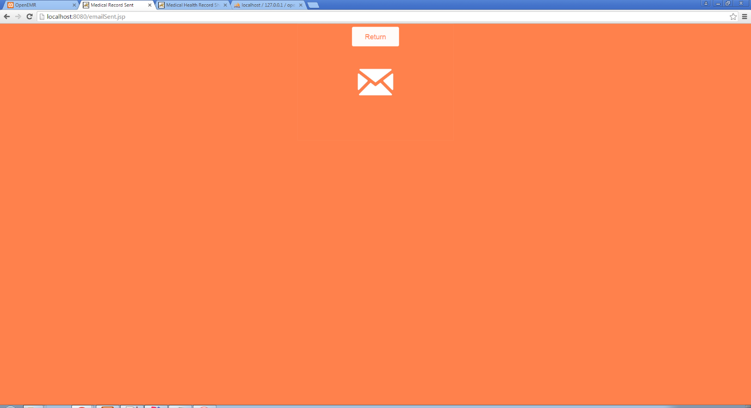

The patient record has been successfully sent!

To decode the record, download the received attachment and store it at some location. Then click on Choose file on the main MHR Sharing page and find the file you just downloaded. Then proceed with entering the last 4 digits of the patient's SSN.

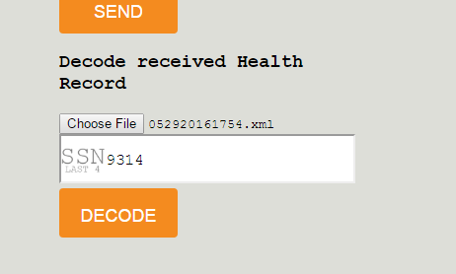

Click decode and you should see the following page where on top you can see the directory where the decrypted CCD file is.

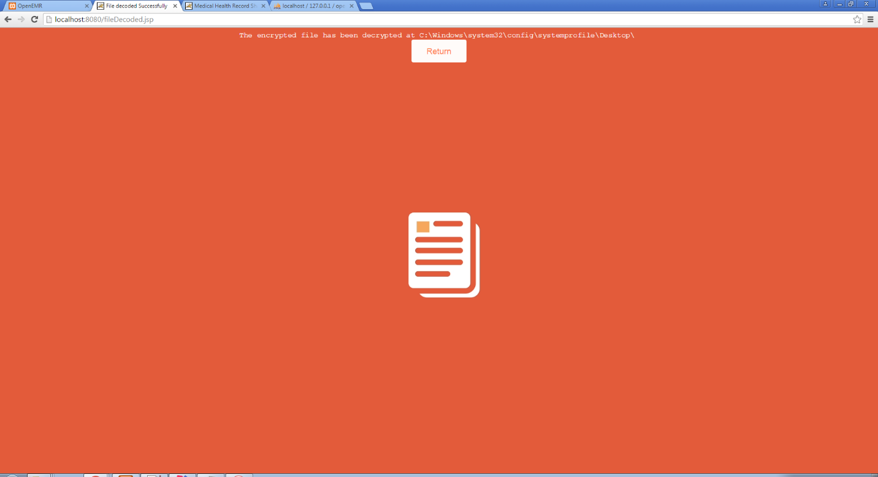

# TESTING DATA

|  |  |  |  |
| --- | --- | --- | --- |
| id | fname | lname | ss |
| 1 | Patrick | Matthews | 764-65-9568 |
| 2 | Benjamin | Berry | 310-40-0579 |
| 3 | Anna | Nichols | 243-59-3979 |
| 4 | Judy | Ray | 729-32-6916 |
| 5 | Brandon | Freeman | 271-84-0225 |
| 6 | Bruce | Daniels | 531-63-5078 |
| 7 | Lois | Mills | 337-45-5495 |
| 8 | Louis | Ryan | 554-51-7240 |
| 9 | Virginia | Rose | 199-15-8432 |
| 10 | Chris | Reed | 642-97-8844 |
| 11 | Henry | Austin | 450-85-5869 |
| 12 | Willie | Wallace | 787-09-9630 |
| 13 | Anne | James | 264-31-4214 |
| 14 | Jacqueline | Cook | 710-15-9877 |
| 15 | Mildred | Bennett | 506-90-3224 |
| 16 | Bobby | Knight | 259-28-3088 |
| 17 | Brian | Gordon | 118-11-4276 |
| 18 | Mildred | Russell | 312-26-4498 |
| 19 | Angela | Lewis | 333-36-6654 |
| 20 | Alice | Owens | 394-26-0860 |
| 21 | Roy | Simmons | 817-27-9020 |
| 22 | Jeffrey | Green | 692-36-7731 |
| 23 | Carl | Robertson | 295-55-7906 |
| 24 | Mark | Turner | 329-02-1812 |
| 25 | Karen | Ferguson | 964-32-9703 |
| 26 | Randy | Morgan | 912-66-5027 |
| 27 | Jessica | Fisher | 495-57-9633 |
| 28 | Nicholas | Webb | 960-03-2219 |
| 29 | Steve | Chavez | 992-72-3503 |
| 30 | Jessica | Elliott | 308-99-6700 |
| 31 | Phyllis | Arnold | 556-09-4011 |
| 32 | George | Mason | 753-11-4670 |
| 33 | Bruce | Reynolds | 367-86-4582 |
| 34 | Mark | Ward | 771-12-3026 |
| 35 | Donna | Collins | 513-80-4204 |

# SOFTWARE LIMITATIONS

This software has the following limitations:

1. Needs tomcat server running besides openEMR’s Apache

2. The php page redirects to our software

3. Manual configuration might be needed for mySQL database connection (see MHRSharing/MailRecord.java line 30)